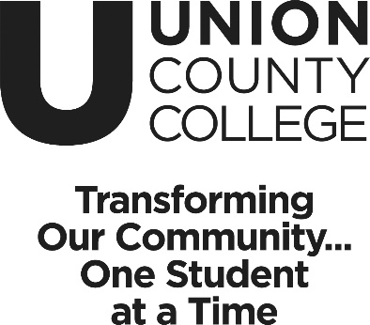 | Continuing Education  New Program Proposal

Instructor Name: | < enter instructor name here >
Address:
Phone:
Email:
Previous Courses Instructed:
Employer:

Proposed Course Title: | < enter here >
Development Timeframe:
Proposed First Offer Date:
Delivery Method:
# Course Hours

Course Description:
< enter course here >

Course Goals and Objectives:
< enter here >

Course Outline by week of Instruction:
< enter here >

Instructional Methods:
< enter here >

Target Audience (Including appropriate professional organizations, certification requirements, etc.)
< enter here >

Benefits of Course to Participants
< enter here >

Relevant Job Titles and Business Sectors That Benefit
< enter here >

Instructional Materials
< enter here >

Course Timeline/Schedule (# of hours, how often class meets)
< enter here >

Grading Method (if applicable)
< here >

Competition for this Program
< enter here >

Key Selling Points (what makes this program unique)
< enter here >

Learning Goals
< enter here >

Learning Assessment Tool
< enter here>

Class room requirements. A/V, tables, chairs, desks, etc.
< enter here>

Please attached current resume.

